**The Excretory System**

Use page 132-33 of the textbook to answer the questions on this page.

1. What is the function of the excretory system?

__________________________________________________________________________________________________________________________________________

1. Why is water important in controlling wastes? __________________________________________________________________________________________________________________________________________
2. Explain how the digestion of proteins produces ammonia and urea. __________________________________________________________________________________________________________________________________________
3. Label the organs involved in the excretory system.

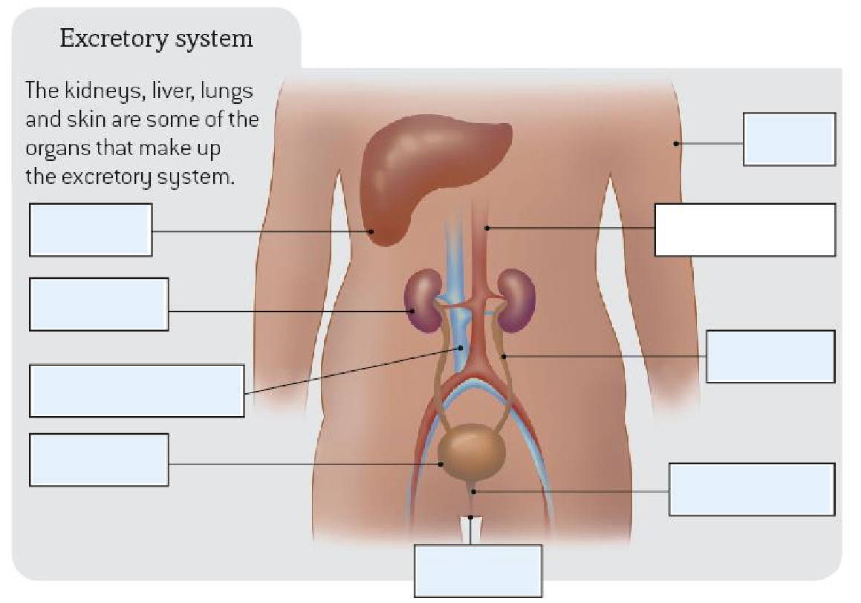

**Waste Disposal in the Body**

Wastes are harmful to the body if they are allowed to accumulate, so we need to get rid of them.

**Complete the table below to summarise the organs in the excretory system**

|  |  |  |
| --- | --- | --- |
| **Organ** | **Waste Removed** | **How the waste is removed** |
|  |  |  |
|  |  |  |
|  |  |  |
|  |  |  |

1. What is excretion?

________________________________________________________________________________________________________________________________________________

1. How does your body get rid of the following wastes?
   1. Heat

__________________________________________________________________________________________________________________________________________

* 1. Urea

__________________________________________________________________________________________________________________________________________

* 1. Carbon dioxide

__________________________________________________________________________________________________________________________________________

1. Why does urine tend to be more concentrated in hot weather?

________________________________________________________________________________________________________________________________________________